**Isolation and Characterization of** [**Terpenoid**](http://en.wikipedia.org/wiki/Terpenoid)**Derivatives from Medical Plant Roots by Thin Layer and Flash Column Chromatography (TLC&FCC) Techniques**

**Alaa J.Mahrath*1, Ghafil S.Hassan 2, Ehab K. Obaid 3**

**Biochemistry Department*1, physiological Department 2 Faculty of Medicine Babylon University.**

**Agriculture Collage Al-Qasim Green University 3**

**Abstract:**

The present work is including separation and identification of triterpenoids like (sterol , [Betulinic acid](http://en.wikipedia.org/wiki/Betulinic_acid) or leanolic acid ) from extracted *Alhagi* roots plant by three stages .The first one involved extracted and identification process of the crude was done by thin layer chromatography (TLC) depending on different in the polarity of solvents of the mobile phase , while the second stage was isolation of the leanolic derivative by flash column chromatography (FCC).The final stage included full elucidation of isolated component by development spectroscopic analysis like furrier transformer Infra Red (FT-IR with KBr disk and ATR mode),1H-NMR ,13C-NMR , MS ,and Elemental analysis(C:H:N) .

keywords: alhaqi , medical plants, sterols , flash column chromatography.

*Corresponding author: E.mail: [alajm68@uobabylon.edu.iq](mailto:alajm68@uobabylon.edu.iq)

**الخلاصة:**

العمل الحالي يتضمن أستخلاص وعزل بعض مشتقات التربينول الدوائية مثل الستيرولات , حمض البيتلنك أو حمض الاولينوليك من مستخلص جذور نبات العاكول الصحراوي بثلاثة مراحل . المرحلة الاولى تتضمن أستخلاص المادة الفعالة وتحديدها بواسطة تقنية كروماتوغرافيا الطبقة الرقيقة وبالاعتماد على الاختلافات في قطبية المذيبات في الطور المتحرك. بينما تضمنت المرحلة الثانية عزل مشتق الاوينوليك بواسطة كروموتوغرافيا العمود المعجلة. المرحلة الاخيرة تضمنت تشخيص المشتق المعزول بالطرق الطيفية المطورة كتقنيات طيف الاشعة تحت الحمراء بطريقتي قرص بروميد البوتاسيوم وبلورة الانعكاس الكلي , طيف رنين الهيدروجين والكربون النووي المغناطبسي , طيف الكتلة والتحليل العنصري (كربون : هيدروجين:النتروجين).

**1. Introduction:**

It's well known that alhagi maurorum has one of the most important medicinal plants.The common names of it's was (Al-akool , and Camel Thorn Plant).Alhagi maurorum or camel thorn is a member of pea family. It is a deep rooted up to 15 feet, while its height is about 1-4 feet. It is used in USSR for camels, sheep and goats **(Kleimenoia L.M., 1984)**. It grows in dry soil because of its deep root. Some researchers have suggested that exhaust food reserves in the roots. **Towhidi A., 2007** stated that alhagi contains 9 % dry matter, 10% crude protein, 43% dry matter digestibility, 38% organic matter which contents minerals and anti-parasitic substance. **Ghane M., and et al, 2008** stated that Alhagi maurorum is used in folk medicine as laxative, expectorant and diuretic**. Marashdah et al, 2006** studied the effects of the extract on mice rectal temperature which decreases from 4.3 – 7.3 Co according the dose by method described by **(Gray and et al, 1987)**. Also they studied the effect of Ahagi extract on rectus abdominis muscle of frog in dose 10 -25 mg/ml according method described by **(Fliesher et al, 1960).** Recently **(Naseri M.K., and et al, 2007)** studied effect of Alhagi extract on gastric ulcer on male mice.

**(Atta A.H., et al, 2010)** proved that Alhagi extract has diuretic effect for this reason, they studied the effect of methanol extract of Alhagi maurorum. They noted that urine and electrolytes excretion similar to furosemide. Also (**Bhavana Srivastava , et al ,2014)** alhagi is use in folk medicine as a remedy for rheumatic pains, bilharziasis and various types of gastrointestinal discomforts, urinary tract diseases and liver diseases . At the present times there is an increasing tendency toward the use of herbal medicine specially in Arab land that reflects the trust and confidence in such remedies **(Marashdah and AL-Hazimi, 2010; Marashdah and Farraj, 2010).** According to previous factsthe analytical studies of this herb was very necessary. Oleanolic acid and ursolic acid are the main active components in fruit of *Ligustrum lucidum* Ait, and possess anticancer, antimutagenic, anti-inflammatory, antioxidative activities (**XiaQ**.**En**,**et** **al,2011**). **Arafa Hamed ,et al,2012)** were isolated successfully new Triterpene glycosides from the Alhagi maurorum. **(Akwasi A.Yeboah,et al,2013)** approved that oleanolic acid (OA) have anti-fertility effect in several animals. **(Babalola T.Ibrahim,et al,2013)** used ursolic acid and oleanolic acid as beneficial potentials in nutrition , cosmetics and drugs. Therefore we became more interested and desirable to investigate in this research to Isolating new components might present in this plant.

**2. Material and Methods:**

**2.1. General procedure for plant preparation:**

The fresh plant roots of alhagi were collected from Al-Mahaweel area in Babylon government during of August 2014 and stored immediately after collection at 8 °C. The samples roots were cleaned and cutting to small pieces for grinding figure (1). Weight of 15 gm of powdered roots were extracted with ethanol by using soxhlet extraction apparatus for about 30 minutes. The crude extract was concentrated under vacuum by using lumpholizer apparatus (Freeze dryer) to produced about (2.4 gm, 16%) of crude extract.

**2.2. General procedure for plant extraction:**

The crude was solvated again in ethanol and subjected to the thin layer chromatography (TLC plate with the following description, Aluminum Silica 60.size 20×20 cm ,Fluorescent Indicator) and eluted with mixture of ,(ethanol :ethyl acetate),(dichloromethane :hexane), and (methanol : chloroform) (10:90) , (20:80),(30:70) ratio respectively. More than three components were observed .They viewed under ultraviolet light at about 257 nm for development spots.

**2.3. General procedure of isolation product:**

The same crude extract directly packed into flash column chromatography (FCC) with the following descriptions (Column size 2.5×50 cm , packed with stationary phase silica gel 60×120 mesh size. The mobile phase used (10:90, ethanol: chloroform) which was the best selection ratio to obtained a pure component of oleanolic acid , melting point = 300 with other ingredients . This procedure is done according to the (**Hari P.Tripathee ,et al,2011**)

**2.4. Analysis Techniques Conditions :**

Electrothermal melting point (Stuart) uncorrected used for determination the melting point of isolated compound. Freeze Dryer (CHRIST,Alpha 1-4 LD, with Vacum Pump RZ 6,up to 4-10-4mbar) . Infra Red spectra were recorded on Bruker –Tensor 27( FT-IR spectroscopy with both KBr disk and ATR Unit). Proton with carbon Nuclear Magnetic Resonance (1H-NMR and 13C-NMR) Bruker, Ultra Shield Spectrometer-300MHz with tetra methyl silane (TMS) as a standard with dimethyl sulfoxide (DMSO) ,and deuteriated water (D2O) as a solvents. Mass spectra were recorded on Shimadzu Qp-2010 Plus,Electron Voltage 70 eV. And Elemental Analysis was recorded using Euro EA 3000. All the chemicals were used in this research including the solvents were from sigma Aldrich company.

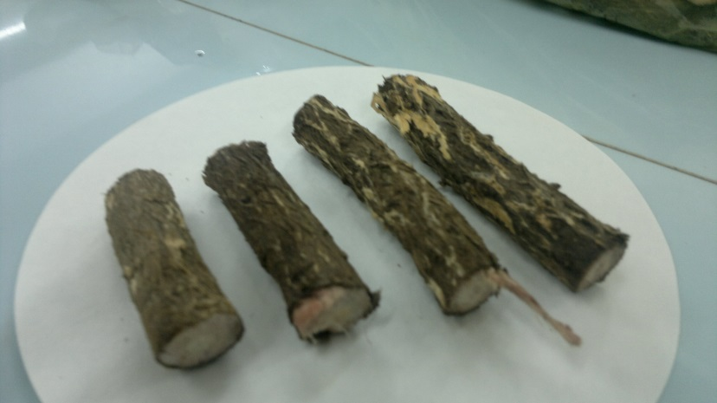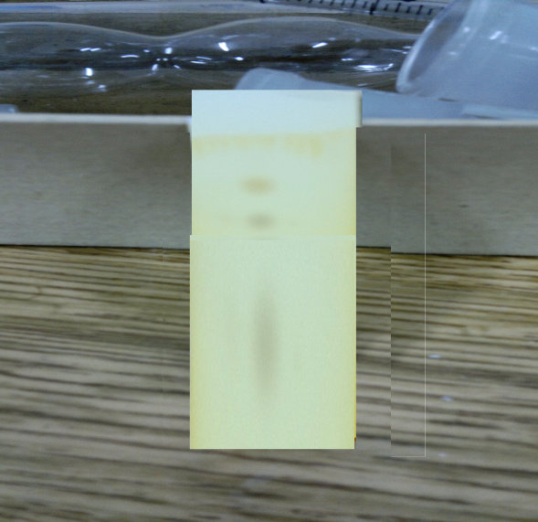



**Figure (1): Section of Alhaqi Roots after Cleaning Figure (2): TLC of Crude extract.**

**3. Results and Discussion:**

The experimental data of spectroscopic analysis showing a good evidence to presence of oleanolic acid or it's derivatives. The TLC analysis of the alhagi crude gives more than two spots with tailing which observed clearly in the methanol: chloroform solvents **figure(2)** . Therefore the separation of these components became very necessary. We used the same mobile phase in the (TLC) to isolate these spots in (FCC) but with different ratio 10:90 .The collection samples from FCC showed there were more than one component. Evaporation the solvent from the solvent under reduces pressure by Freeze Dryer to get on oily sample .when treated with n-pentane a solid component formed with m.p 309 decom. .The Infra Red spectroscopy of this sample give us a clear evidence by presence of hydroxyl groups **(OH)** at stretching frequency ⱱ= (3303-3350 cm-1) in **figure(3a)**. Also the strong absorption band at ⱱ= (1707-1730 cm-1) which refer to the carbonyl group **(C=O)** of carboxylic acid and ester while the rest of peaks at about ⱱ =(2937, 1445- 1229 cm-1) belong to CH=C-, CH2 and CH3 respectively with finger print region **(Pavia L.D. et al,2009)**.On the other hand 1H-NMR in DMSO solvent **figure (3a)** showed clearly presence of all the methyl group (CH3), methylene (CH2) in addition two of hydroxyl groups (alcoholic and Carboxylic site) as follows: ( s,9H,3CH3, methyl groups) at δ = 1.22 ppm , (s,12H,4CH3 ,methyl groups) at δ=3.34-3.55 ppm, (m,20H,10CH2, methylene groups)at about δ=3.62-3.90 ppm , (d, 1H, OH, alcoholic group) at δ= 4.40-4.55 ppm, (s,1H,OH,carboxylic group)at about δ=4.82 ppm and (m, 1H, CH=C, alkene group) at δ = 5.1-5.20 ppm. The most important fact was disappearance of both hydroxyl groups (alcoholic and carboxylic ) when measured in deuterium water H2D as shows in **figure (3b)**. Mass spectra of isolated compound confirmed presence of Oleanolic acid which shown (m/z,%) =456[M++4],with relative intensity 10%. Other fregmant were about; (350,9) , (280,92),(200,70).The last evidence of Isolation (OA) was elemental analysis which clearly a proved to be identical till 92% with virtual calculation ,(calculated /**experimental**); (**C**, 78.68/ **79.16**; **H**, 10.47/ **11.09** ; **O**, 10.84/**11.31**). From all the above evidence we can judge that the isolated product is triterpenoid derivatives like type A or B.



**[Type A]** **[Type B]**

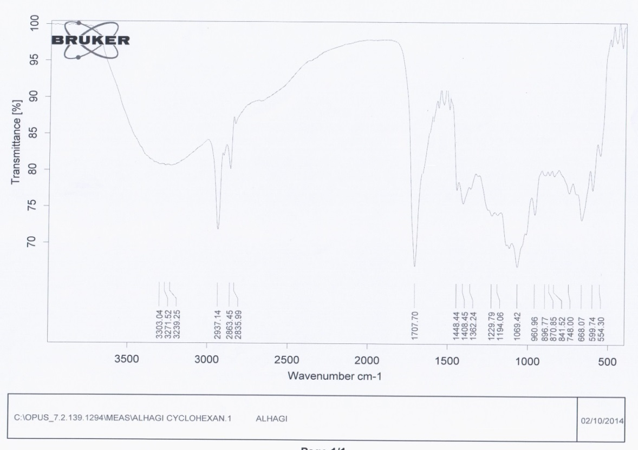



**Figure (3a): Infra Red Spectra (FT-IR) of Oleanolic acid in ATR unit at 22 °C.**

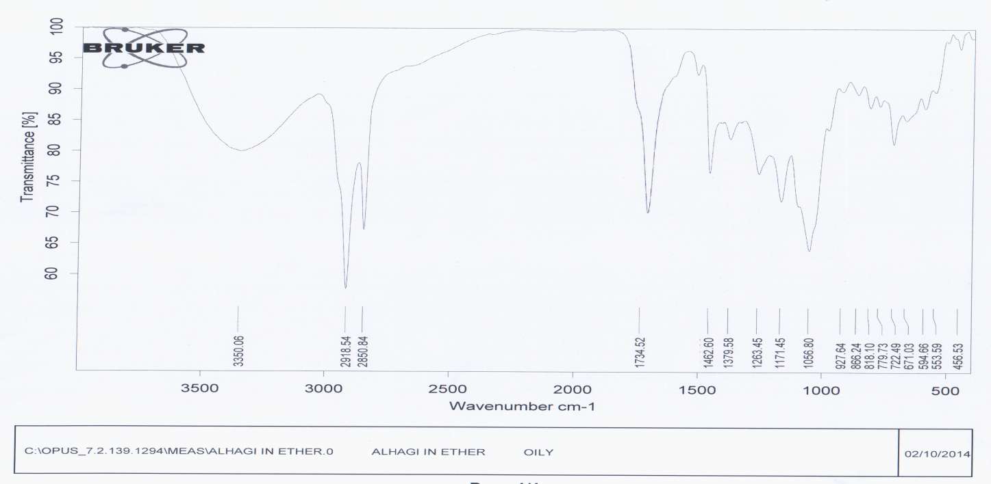



**Figure (3b): Infra Red Spectra (FT-IR) of Oleanolic acid in KBr disk at 22 °C.**

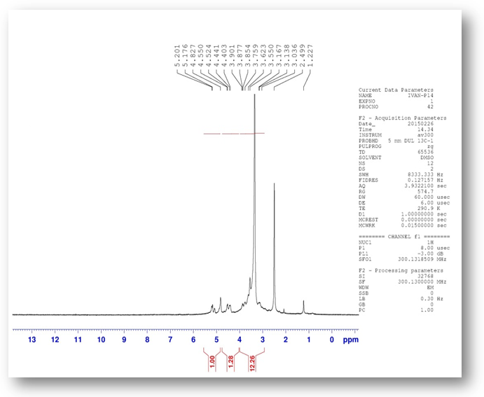



**Figure ( 4a ): 1H-NMR spectra of the isolated product (triterpenoid) in DMSO solvent .**

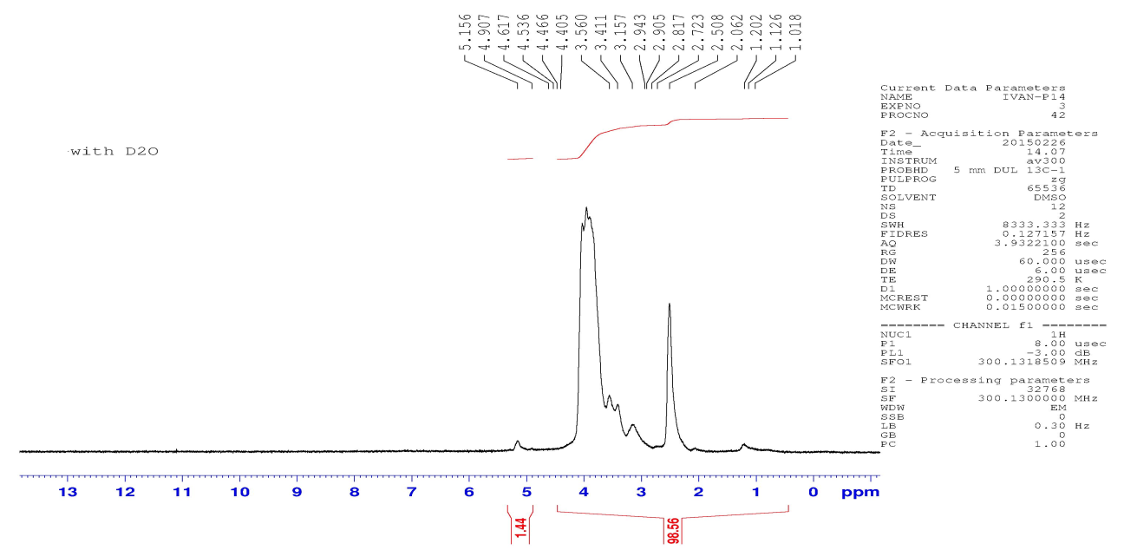



**Figure (4b): 1H-NMR Spectra of Isolated product (Triterpenoid) in DMSO+D2O solvents.**

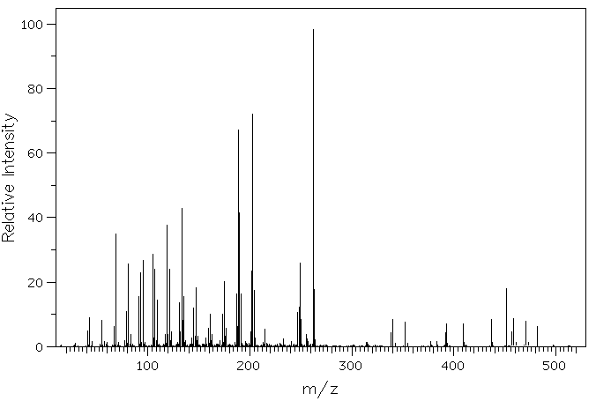



**Figure (5): Mass spectra of Oleanolic acid from Alhagi Roots.**

**4. References:**

1. Kleimenova , L.M.Problemy Ovoenya Pustye,plant pest risk assessment for camel thorn 1984,4,62-64.

2. Towhidi, A. Nutritive value of some herbage for dromedary camel in Iran. *Pak. J. Biol. Sci.*,2007, 10: 167-170.

3.Marashdah M.S., and Farraj A.I.,. Pharmacological activity 2% aqueous acetic acid extract of Alhagi maurorum root.Journal of Saudi Chemical Society;2010,14,247.

4. Gray J.A., Goodwin G.M., Heal D.J., and Groon A.R.,. Hypothermia induced by blaclofen, apposible index of GABAB receptor function in mice, it is enhanced by antidepressant drugs. Br.J. Parmacol. 1987, 92, 863 .

5- Fleisher J.H., Corrigan L.P., and Howard J.W., Reciprocal potentiating frog rectus abdominis muscle. Br.J. Pharmacol. Chemother. 1960, 15, 23.

6. Naseri M.Kazem,Mard A.Seyyed,Gastroprotective Effect of Alhagi Maurorum on experimental Gasteric Ulecer in Rat,Orginal Article,Pak.J.Med Sci.2007,23,4,570.

7. Atta A.H., Nasr S.M , Mouneir S.M., AL-Wabel N.A., Essawy S.S.,. Evaluation of the diuretic effect of conysa dioscorides and Alhagi maurorum . International journal of pharmacy and pharmacology; 2010,2 ,3, 162 .

8. Bhavana Srivastava, Himanshu Sharma, Yadu Nandan Dey, Manish M Wanjari, Ankush D Jadhav , 'a review of its phyto-chemistry, pharmacology, folklore claims and Ayurvedic studies'. International Journal of Herbal Medicine 2014; 2 ,47.

9. En-Qin Xia, Bo-Wei Wang, Xiang-Rong Xu, Li Zhu, Yang Song and Hua-Bin Li; Microwave-Assisted Extraction of Oleanolic Acid and Ursolic Acid from *Ligustrum lucidum* Ait, International Journal of Molecular Sciences, 2011, *12*, 5319.

10. Arafa Hamed, Angela Perrone, Usama Mahalel, Wieslaw Oleszek, Anna Stochmal, Sonia Piacente,. Oleanane glycosides from the roots of Alhagi maurorum; Phytochemistry Letters; 2012, 5,782.

11. Akwasi Ampofo-Yeboah, Helet Lambrechts, Danie Brink, Fletcher Hiten and Evans Afriyie Gyawu: Analysis of Oleanolic Acid and Ursolic Acid, Potential Antifertility Agents in Moringa , Journal of Agricultural Science and Technology 3 (2013) 989.

12. Ibrahim T Babalola ,Francis O. Shode, Acid A Potential Pentacyclic Triterpene Natural Product; Journal of Pharmacognosy and Phytochemistry, 2 (2013),2,214.

13. Hari P.Tripathee , Ram P.Shama ,and Yagna P.Timilsina, Ramayan Pathak and Krishna P. Devkota ; Nepal Journal of Science and Technology 12 (2011) 111.

14. Donald L.Pavia ,Cary M.Lampman,George S.Kriz ,and James R.Vyvyan ;Introduction to Specytoscopy (2009), 4th edition,Brooks/Cole ,USA.